Reflective 2

I have chosen the following surveys for my reflective piece; the 2001 Census for England and Wales (Jha, 2003) and Planned Parenthood 2015 Congressional presentation in the USA (Politifact, 2017). I selected these two surveys due to their contrasting purposes and outcomes. The 2001 Census for England and Wales provides examples where a survey is incomplete and leads to important data being omitted. This may have varied outcomes with a huge ethically impact as this data is issued to represent people for at least 10 years in governmental planning. In the second example, the planned parenthood survey was subjected to manipulation which may be the result of malicious actions for a political goal.
The British government collects data every ten years via a census survey (Office of National Statistics, 2001). This has a wide and important impact for succeeding government planning and is of the upmost importance that this data is balanced, comprehensive and accurate. The 2001 census unfortunately missed several tens of thousands of young men in inner cities. This was especially prevalent in Westminster council, where the council numbers and the 2001 census had tallied as many thousand short. Policies were created due to this miscalculation that lasted for a decade. Thus, the initiatives, plans and operational budgeting that were being implemented did not truly reflect the needs of the population.

In a 2015 Congressional pro-life hearing, advocates tried to claim that increased abortion services had resulted in a reduction in cancer screening services. The design of the dual axes on the chart presented is misleading as it is not being used appropriately in terms of scale. A collated chart provides a much more representative graph for the data gathered as both sets of data are displayed on the same axis scale.

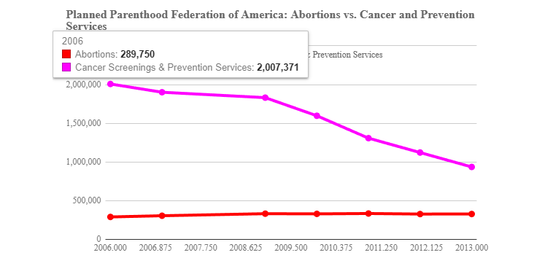

The impression using a dual axes scale is very different as seen below. One is being measured in millions and other in tens of thousands. This leads to a graph which looks as though there is a correlation but in fact is a gross manipulations of data.
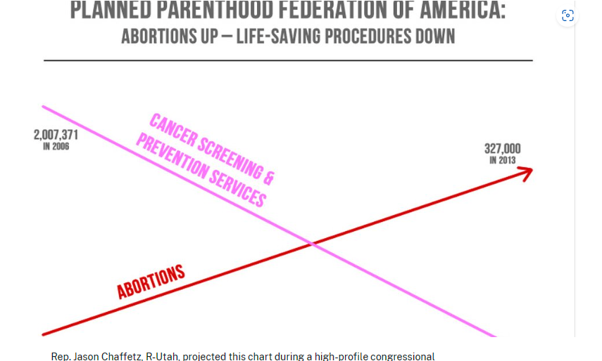

References
Jha, A. (2003). What went wrong with the 2001 census?. [Online]. The Guardian. Available at: https://www.theguardian.com/science/2003/sep/11/thisweekssciencequestions [Accessed 5 November 2023].
Office of National Statistics. (2001). Census 2001 questionnaires. [Online]. Office of National Statistics. Available at: https://www.ons.gov.uk/census/2001censusandearlier/aboutcensus2001/census2001forms [Accessed 5 November 2023].
Politifact. (2017). The Poynter Institute. [Online]. Politifact. Available at: https://www.politifact.com/factchecks/2015/oct/01/jason-chaffetz/chart-shown-planned-parenthood-hear [Accessed 5 November 2023].

